**Project Description:**

ROV, or Reminder of Vitality, is a hydration reminder app developed by Team HydraTech, aiming to help users maintain optimal hydration levels throughout the day. Created by Smith and Johnson, the app leverages GPS-based reminders and customizable settings to provide personalized hydration prompts. ROV's primary task is to track daily water intake and send timely reminders based on user preferences and location, encouraging consistent hydration habits. The intended users are individuals of all ages who seek to improve their hydration practices, including office workers, athletes, and health-conscious individuals.

**Requirements Summary:**

Table 1. System Requirements

To cater to a wide range of Android devices, the ROV app will function with a minimum of a single core processor, 2 GB of RAM, and Android version 5.0 (Lollipop). For optimal performance, we recommend a quad-core processor, 4 GB of RAM, and Android version 8.0 (Oreo). The app is designed to be lightweight and efficient, ensuring accessibility even on lower-end devices.

**Prototype Description:**

The prototype for the ROV app was created using Figma, an interactive prototyping software and website. Figma allows for easy distribution to testers via links sent by the developers, enabling efficient feedback collection and iteration.

**User Scenario:**

Emma and Jack, both office workers with busy schedules, often forget to drink enough water throughout the day. This has led to them feeling fatigued and less productive at work. They've tried using basic reminder apps before, but these apps didn't adapt well to their varying schedules and preferences.

One day, Emma hears about the ROV app from a colleague who praises its effectiveness in improving hydration habits. Intrigued, she downloads ROV from the app store and sets it up to remind her to drink water every two hours. Emma notices immediate improvements in her energy levels and productivity. Impressed, she recommends ROV to Jack, who also struggles with hydration.

**Rehydrate Mock-up/Prototype**:

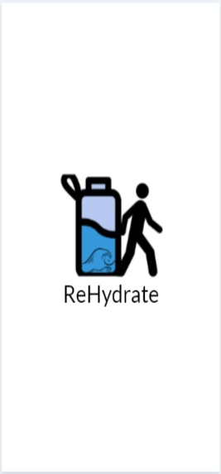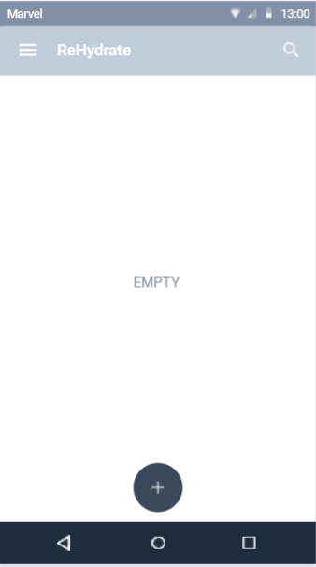

|  |  |  |  |  |
| --- | --- | --- | --- | --- |
| **Splash Screen** | **Navigation** | **Main Menu** | |  |
| The Splash | **Drawer** |  | |  |
|  | The Main Menu | |  |
| Screen contains | The Navigation | is where the user | |  |
| the app’s logo | Drawer lets users | Will input a new hydration reminder | |  |
| and will be | navigate through |  |
| displayed for 2 | the app settings |  |
| seconds on | or when they |  |
| startup. | want to exit the |  | |  |
|  |  | |  |
|  | app completely. |  | |  |

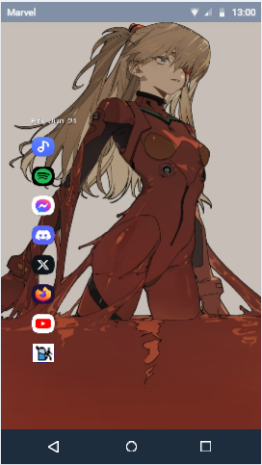

**Home Screen**

The Home

screen is where

the users will

enter the app

when exiting it.

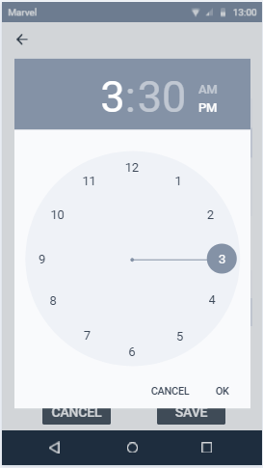

**Time Select**

This will open when

the user decides to

input their own time

|  |
| --- |
| **Prototype in Laptop / Wider Screen** |
| This is how the prototype will look in a wide screen. Mainly |
| laptops or tablets. |
|  |
|  |
|  |

**Prototype Flow**:

Main Screen:

Figure 1. Entering and Exiting Prototype

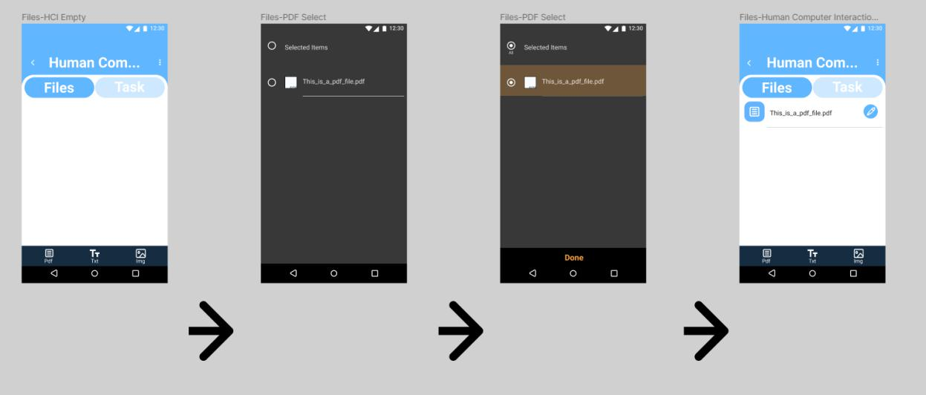

**Rationale:**

The development of the ROV app is driven by the need to address the widespread issue of inadequate hydration among individuals with busy lifestyles. Traditional hydration reminders are often generic and fail to account for users' specific routines and preferences, leading to inconsistent water intake. By integrating GPS-based reminders and customizable settings, ROV aims to provide a personalized hydration experience that fits seamlessly into users' daily lives. The app's design prioritizes user engagement and effectiveness, ensuring that reminders are timely and relevant. This targeted approach is expected to significantly improve hydration habits, enhancing overall health and productivity.

**Changes to the Requirements:**

During the development of the ROV app, several changes to the initial requirements were made based on user feedback and testing outcomes. Initially, the app was designed to function with a minimum of a single core processor, 2 GB of RAM, and Android version 5.0 (Lollipop). However, to enhance performance and user experience, the minimum requirements were adjusted to a dual-core processor and Android version 6.0 (Marshmallow). Additionally, the permissions initially focused on notifications and storage have been expanded to include access to location services to enable the GPS-based reminder feature. These changes ensure the app runs more smoothly and offers more robust functionality to meet user needs effectively.

**Initial Evaluation Plan:**

The initial evaluation plan for the ROV app focuses on assessing usability, functionality, and user satisfaction. The evaluation will be conducted in three main phases:

1. **Usability Testing**:
   * **Objective**: To ensure the app's interface is intuitive and easy to navigate.
   * **Method**: Recruit a group of 20 users to perform specific tasks using the app, such as setting up reminders, inputting water intake, and customizing notification settings.
   * **Metrics**: Task completion rate, time taken to complete tasks, and user error rate.
2. **Functionality Testing**:
   * **Objective**: To verify that all features work as intended, especially the GPS-based reminders and customization options.
   * **Method**: Conduct systematic testing of each feature with a smaller group of 10 users who will use the app in various environments (e.g., at home, at work, outdoors).
   * **Metrics**: Feature success rate, bug reports, and system performance metrics (e.g., app load times, battery usage).
3. **User Satisfaction Survey**:
   * **Objective**: To gather user feedback on their overall experience with the app.
   * **Method**: Distribute a survey to all participants post-testing, asking them to rate their satisfaction on a 5-point Likert scale and provide qualitative feedback.
   * **Metrics**: Average satisfaction score, user comments, and suggestions for improvement.

These evaluation phases will provide comprehensive insights into the app's strengths and areas for improvement, guiding further development and refinement.

**Population**

The target population for the initial evaluation of the ROV app includes a diverse group of individuals who could benefit from improved hydration habits. This group comprises office workers, who often forget to drink water due to busy schedules and need reminders to maintain productivity and overall health; athletes, who require consistent hydration for peak performance and benefit from personalized hydration tracking and reminders; students, who face the challenge of balancing academic work and hydration and need convenient reminders to stay hydrated throughout the day; and health-conscious individuals, who are actively seeking ways to improve their health routines and are interested in advanced tracking and customization features. The initial evaluation will involve 40 participants, with 10 individuals from each of these groups, ensuring the app's effectiveness and usability across different lifestyles and hydration needs.

**Prototype Tasks**

The tasks for this Prototype are split into three (3) different Sections: Main Screen, Setting the Hydration Reminder task, and the total amount of hydration. Below are some of the tasks that the selected participants will be asked to perform for each section to showcase the Prototype’s functionality:

* Enter and Exit the Prototype (**Main Screen**)
* How easy will the user be able to navigate the application.
* Participants will be tasked in creating a hydration reminder (**Hydration Reminder Task**)
* Participants will be tasked in deleting hydration reminders (**Folder Task**)
* Participants will be tasked to edit the hydration amount (**Total Amount of Hydration Task)**

Reasons that these tasks were selected for the participants since the Prototype was designed with these measures in mind:

* Ease of navigation on the prototype
* The allowance of users to do CRUD (Create Read Update Delete)

**Roles**

The team has will gather at the very least 10 participants when conducting this evaluation.

With this is mind, team will split the population and have similar roles in this evaluation.

|  |  |
| --- | --- |
| **Developer / UI Designer Member** | **Task(s)** |
|  |  |
| Christopher Jacob Ong | Will be recording time users interact with a |
|  | task section, taking notes of the user’s |
|  | experience, and relay the task that the |
|  | participant will do. |
|  |  |
| Sebastian Vidal | Will be recording time users interact with a |
|  | task section, taking notes of the user’s |
|  | experience, and relay the task that the |
|  | participant will do. |
|  |  |

Table 1. Team Member Tasks

|  |  |  |  |  |
| --- | --- | --- | --- | --- |
|  | Within 1 minute or Below | Highly Acceptable | Successful |  |
| Main Screen |  |  |  |  |
| Above 1 minute | Not Acceptable | Unsuccessful |  |
|  |  |
|  |  |  |  |  |
|  | Within 2 minutes or below | Highly Acceptable | Successful |  |
| Hydration Reminder Task |  |  |  |  |
|  | Above 2 minutes | Not Acceptable | Unsuccessful |  |
|  |  |  |  |  |
|  | Within 2 minutes or below | Highly Acceptable | Successful |  |
| Total Amount of Hydration Task |  |  |  |  |
|  | Above 2 minutes | Not Acceptable | Unsuccessful |  |
|  |  |  |  |  |
| Table 2. Time Interpretation | |  |  |  |

Table 3 represents the interpretation above represents how the team will be interpreting the time spent with each participant in their tasks. The table will be used as a guideline to interpret if the design of given task is successful or not at a given task.

**Participant Survey and Feedback**

**After conducting the online test,**

|  |  |
| --- | --- |
| **DATA GATHRERING** | **DESCRIPTION** |
| **METHOD** |  |
| Survey (Quantitative) |  |
|  | Following the online test, the group will distribute a survey to  the participants to compile information regarding the user's encounter with the prototype that the group will evaluate using a 5-point Likert scale (5-Point Likert Scale Interpretation; see Table 5). |
|  |  |
|  |  |
| Feedback (Qualitative) | The team's survey will complement the section on feedback. |
|  | to assist users/participants in voicing any worries or problems with the prototype that need attention. |
|  |  |

Table 3. Data Gathering Methods

The ROV Prototype online test will be conducted by the team using the various data collection methods that are mentioned in the above table.

|  |  |  |
| --- | --- | --- |
| **Question** | **Method of Answer** |  |
| **Section 1** | |  |
| Participant Number | Short Answer |  |
| How easy was it to navigate through the |  |  |
| different sections of the app? |  |  |
| How easy was it to set up a hydration | 5-Point Scale |  |
| reminder? |  |  |
| How user-friendly do you find the |  |  |
| overall design of the app? |  |  |
| **Section 2: Features of the Prototype** | |  |
| Navigation Menu |  |  |
| Accessing reminder |  |  |
| Renaming a reminders |  |  |
| Creating reminders | 5-Point Scale |  |
| Deleting reminders |  |  |
| Tracking |  |  |
| Reminder settings |  |  |
| Push Notifications |  |  |
| **Section 3: Feedback Section** | |  |
| Your Feedback | Short Answer |  |

Table 4. Survey Questionnaire

Table 5. The table above presents the Questions that will be present in the survey for this Prototype.

**Task**

**Time to Accomplish Tasks**

**Interpretation**

**Classification**

|  |  |  |  |
| --- | --- | --- | --- |
| **Scale** | **Range Value** | **Interpretation** | **Classification** |
| 5 | 4.50-5.00 | Apparent |  |
|  |  |  | Successful |
| 4 | 3.50-4.49 | Somewhat |  |
| 3 | 2.50-3.49 | Neutral | Neutral |
|  |  |  |  |
| 2 | 1.50-2.49 | Not Apparent |  |
|  |  |  | Unsuccessful |
| 1 | 1.00-1.49 | Strongly Not Apparent |  |

Table 4. 5-Point Likert Scale Survey Interpretation

The interpretation of the survey questions provided to the participants is shown in Table 5. The purpose of the survey is to determine whether the layout and features offered are beneficial to students who struggle with pacing.

**Heuristic Evaluation**

Evaluation of SASHA will also use the 10 Usability Heuristic method of Evaluation.

*Visibility of System Status*

The Prototype will keep the participants informed on what is happening in the Prototype.

*Match Between System and Real World*

The prototype speaks the user’s language, with familiar words, phrases, and concepts rather than system oriented terms. Follow real-world conventions, making information appear in a natural and logical order.

*User control and Freedom*

The Prototype offers to deal with mistake provided clearly marked “Emergency Exit”. To leave the unwanted state without going through an extended an extended dialogue. Support undo and redo.

*Consistency and Standards*

Users will not have to worry whether different words, situations, or actions mean the same thing.

*Error Prevention*

Error Messages are Carefully designed which prevents a problem from occurring in the first place.

*Recognition rather than recall*

Make objects, actions, and options visible. The user does not have to remember information from one part of the dialogue to another. Instructions for use of the prototype is visible and easily retrievable whenever appropriate.

*Flexibility and Efficiency of Use*

The prototype caters to both experienced and inexperienced users. Users readily tailor frequent actions

*Aesthetic and Minimalist Design*

The prototype does not contain information which is irrelevant or rarely needed. Every extra unit of information in a dialogue competes with the relevant units of information and diminishes their relative visibility.

*Help Users Recognize, Diagnose, and Recover from Errors*

Error messages are explained in plain language (no codes), precisely indicate the problem, and constructively suggest a solution.

*Help and Documentation*

User can easily find help and documentation when need to interact with the prototype.

This information is easy to search for.

**Participant Survey and Feedback**

**After conducting the online test,**

|  |  |
| --- | --- |
| **DATA GATHRERING** | **DESCRIPTION** |
| **METHOD** |  |
| Survey (Quantitative) | After the Online Testing, the team will be handing out a survey to |
|  | the participants to gather data for the user’s experience with the |
|  | prototype which the team will be interpreting in a 5-point Likert |
|  | scale (**Refer to Table 5**. **5-Point Likert Scale Interpretation**). |
|  |  |
| Feedback (Qualitative) | The survey that the team provided will support a Feedback section |
|  | to help users/participants speak out concerns or issues with the |
|  | prototype that needs to be addressed. |

Table 2. Data Gathering Methods

The table above showcases the three (3) different data gathering methods the team will be using while conducting the online test of the SASHA Prototype.

|  |  |  |
| --- | --- | --- |
| **Question** | **Method of Answer** |  |
| **Section 1** | |  |
| Participant Number | Short Answer |  |
| On a scale of 1 to 5 how would you rate your |  |  |
| experience with the Sasha Prototype |  |  |
| On a scale of 1 to 5 how was the UI design of | 5-Point Scale |  |
| the prototype |  |  |
| How easily were you able to follow the tasks |  |  |
| provided |  |  |
| **Section 2: Features of the Prototype** | |  |
| Navigation Drawer |  |  |
| Accessing Files |  |  |
| Renaming a File/Folder |  |  |
| Importing PDF or IMG files |  |  |
| Creating or Adding Folders, Text Files, | 5-Point Scale |  |
| Tasks, and Quiz Files |  |
| Creating Folders, Text Files, Tasks, and Quiz |  |  |
| Files |  |  |
| Quiz Making |  |  |
| Quiz Taking |  |  |
| Sorting of Files and Folders |  |  |
| Deleting Files or Folders |  |  |
| **Section 3: Feedback Section** | |  |
| Your Feedback | Short Answer |  |

Table 4. Survey Questionnaire

The table above presents the Questions that will be present in the survey for this Prototype. This survey will be handed to Participants after the Test using links. The Survey can still be viewed through this link <https://forms.gle/qBqTbYGdGLQY133z9>.

**Task**

**Time to Accomplish Tasks**

**Interpretation**

**Classification**

|  |  |  |  |
| --- | --- | --- | --- |
| **Scale** | **Range Value** | **Interpretation** | **Classification** |
| 5 | 4.50-5.00 | Highly Acceptable |  |
|  |  |  | Successful |
| 4 | 3.50-4.49 | Acceptable |  |
| 3 | 2.50-3.49 | Moderately Acceptable | Neutral |
|  |  |  |  |
| 2 | 1.50-2.49 | Fairly Acceptable |  |
|  |  |  | Unsuccessful |
| 1 | 1.00-1.49 | Not Acceptable |  |

Table 5. 5-Point Likert Scale Survey Interpretation

Table 5 represents the Interpretation of the survey questions given to the participants. The survey will be used as to interpret whether the design and features presented are successful and useful for students who suffer from pacing issues.